Playlist for Backend development for SDE-III
🎥 BACKEND & MICROSERVICES — 30 DAY YOUTUBE PLAYLIST
⏱ Duration: 30 Days
🎬 Video Length: 45–60 minutes each
🎯 Outcome: Strong Backend → Microservices → System Design Ready

🟢 PHASE 1 — JAVA BACKEND CORE (Day 1–5)
Goal: Java like a production backend engineer
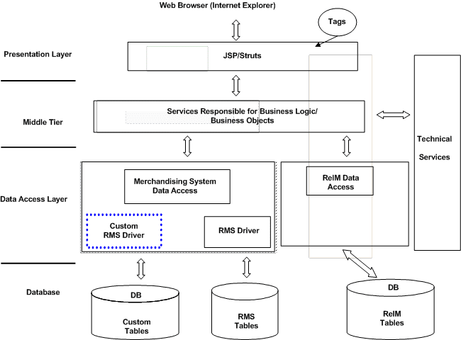
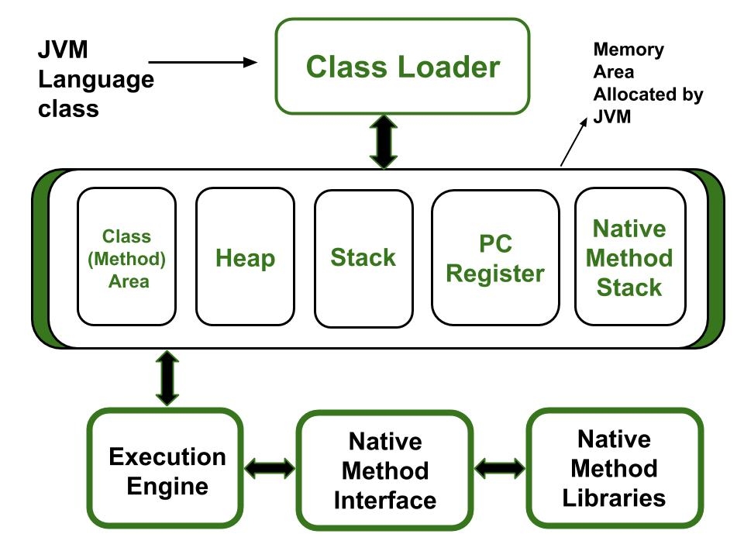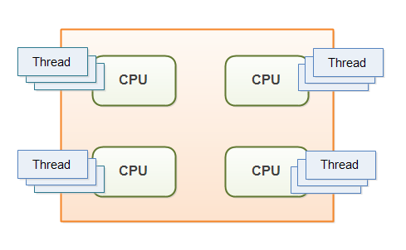

Day 1
▶ Java for Backend Engineers
- JVM internals
- Memory, GC
- What matters in interviews
Day 2
▶ OOPS in Real Backend Systems
- Composition vs Inheritance
- SOLID intuition (no theory overload)
Day 3
▶ Java Collections Deep Dive
- HashMap internals
- Performance & pitfalls
Day 4
▶ Java 8+ Features for Backend
- Streams, Optional
- Functional style in services
Day 5
▶ Multithreading & Concurrency
- Synchronization
- Locks, Volatile
- Real backend use cases

🟣 PHASE 2 — SPRING BOOT STRONG FOUNDATION (Day 6–12)
Goal: Production-grade Spring Boot

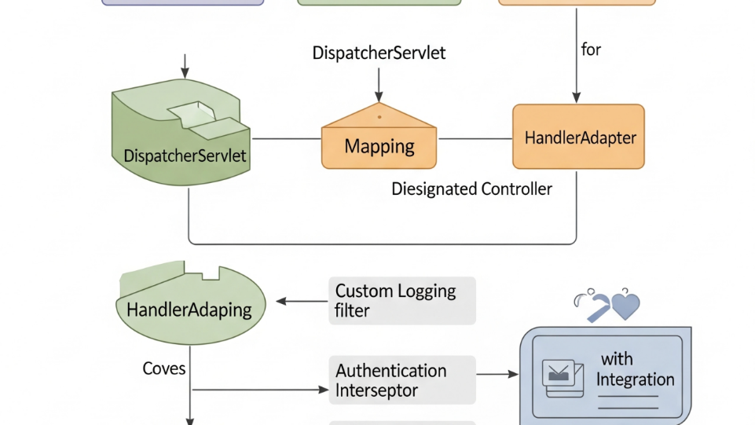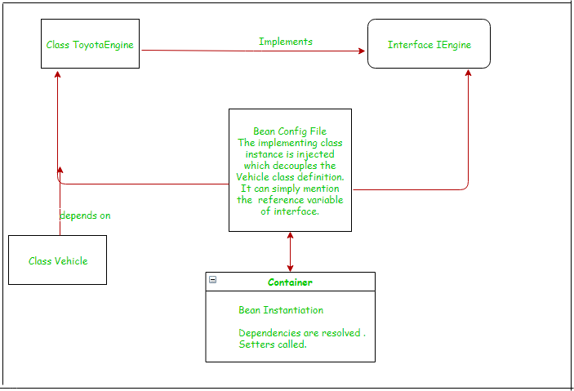

Day 6
▶ Spring Boot Internals
- Auto-configuration
- Project structure
Day 7
▶ REST Controllers + Service Layer
- Clean API design
- Layered architecture
Day 8
▶ JPA + Hibernate Deep Dive
- Entities vs DTO
- Relationships
Day 9
▶ Hibernate Performance
- Fetch types
- N+1 problem
- Pagination
Day 10
▶ Transactions & Data Integrity
- @Transactional
- Isolation levels
Day 11
▶ Exception Handling & Validation
- Global exception handling
- Custom error responses
Day 12
▶ Logging, Filters & Interceptors
- Request tracing
- Correlation IDs

🔵 PHASE 3 — FIRST MICROSERVICE (Day 13–16)
Goal: Build a real backend service
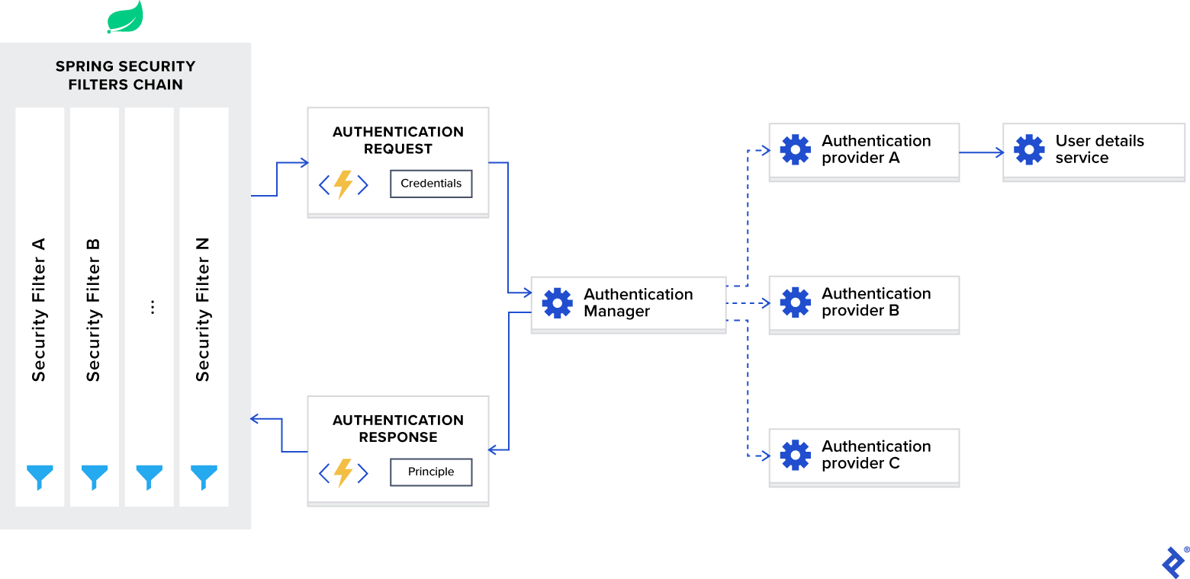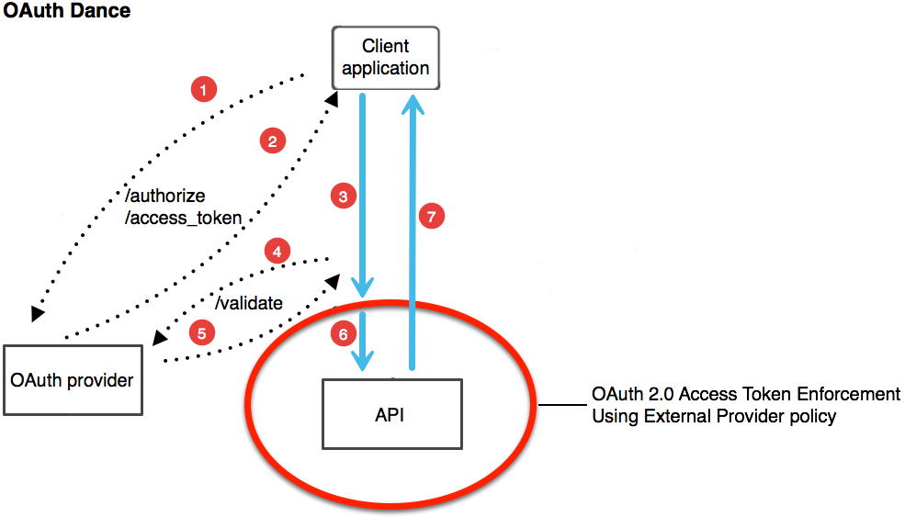

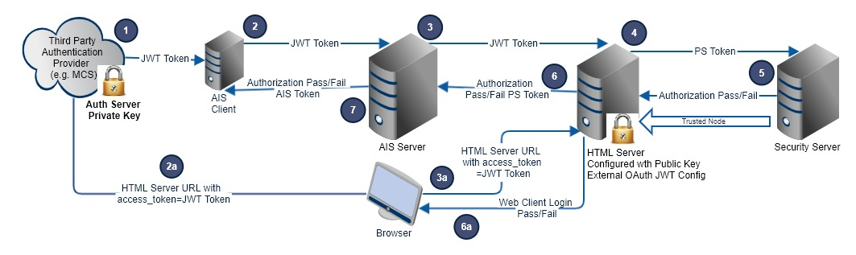
Day 13
▶ Designing User Service
- DB schema
- API contracts
Day 14
▶ User Registration & Login
- Password hashing
- Best practices
Day 15
▶ JWT Authentication & Authorization
- Token flow
- Role-based access
Day 16
▶ CRUD APIs + Security Hardening
- Validation
- Common security bugs
📌 Result: Interview-ready standalone microservice

🏗️ PHASE 4 — MICROSERVICES ARCHITECTURE (Day 17–23)
Goal: Distributed system thinking
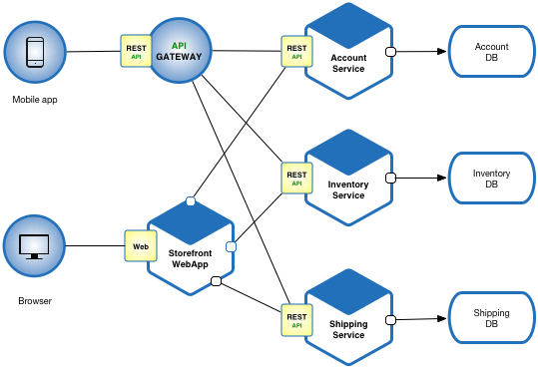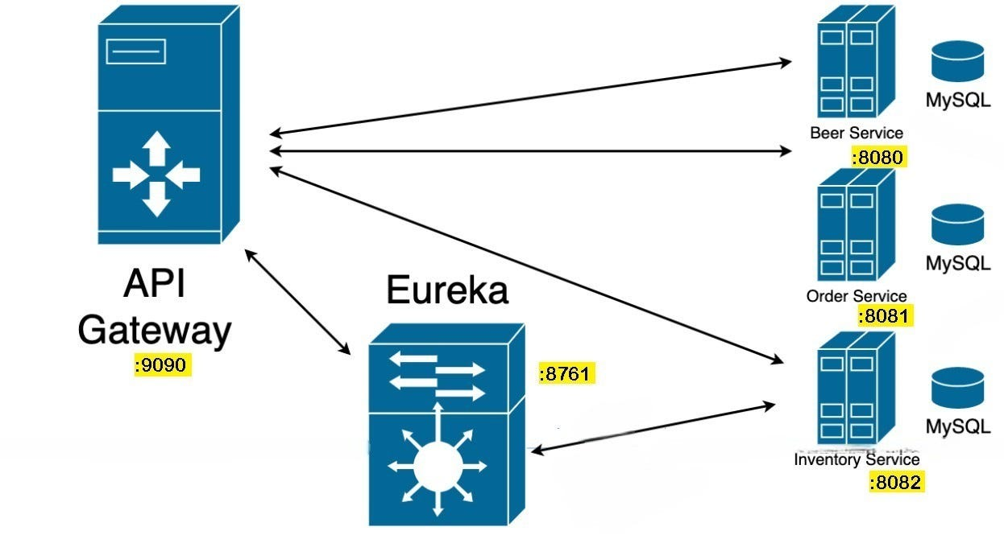
Day 17
▶ Monolith vs Microservices
- When microservices FAIL
Day 18
▶ Service Discovery (Eureka)
- Why & how it works
Day 19
▶ API Gateway (Spring Cloud Gateway)
- Routing
- Auth at gateway
Day 20
▶ Inter-Service Communication
- Feign Client
- Timeouts
Day 21
▶ Resilience Patterns
- Circuit Breaker
- Retry
- Rate Limiter
Day 22
▶ Distributed Transactions Problem
- Why 2PC fails
- Microservice consistency
Day 23
▶ Failure Scenarios & Debugging
- Real production incidents

🟠 PHASE 5 — MESSAGING + CACHING (Day 24–26)
Goal: Async & high performance systems
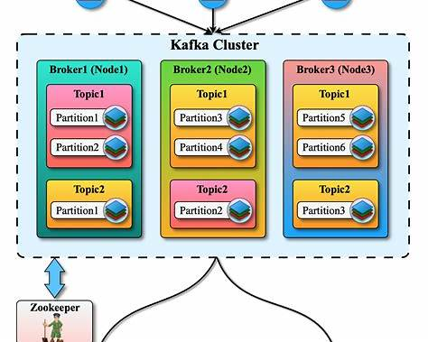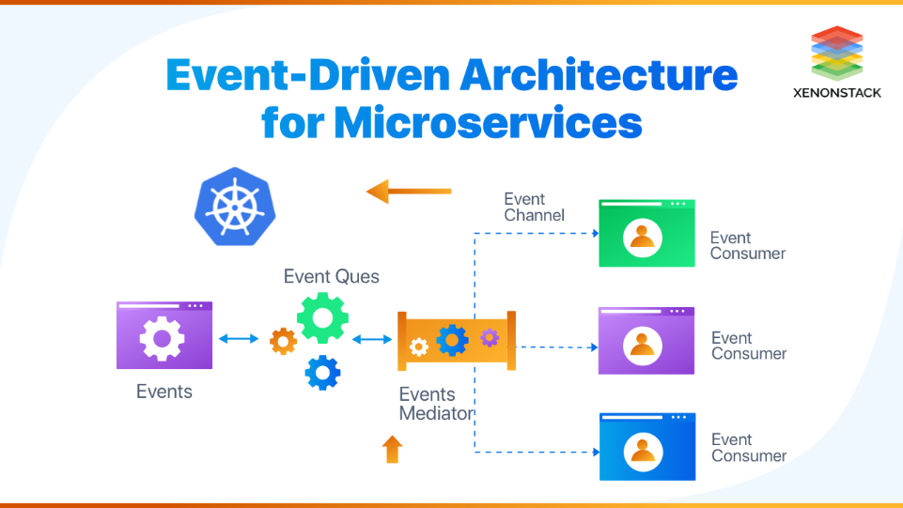

Day 24
▶ Kafka Fundamentals
- Producer, Consumer
- Topics & partitions
Day 25
▶ Order → Payment Async Flow
- Kafka reliability
- Exactly-once intuition
Day 26
▶ Redis Caching
- Cache-aside pattern
- Cache invalidation

🐳 PHASE 6 — DOCKER & KUBERNETES (Day 27–29)
Goal: Deployment-ready engineer
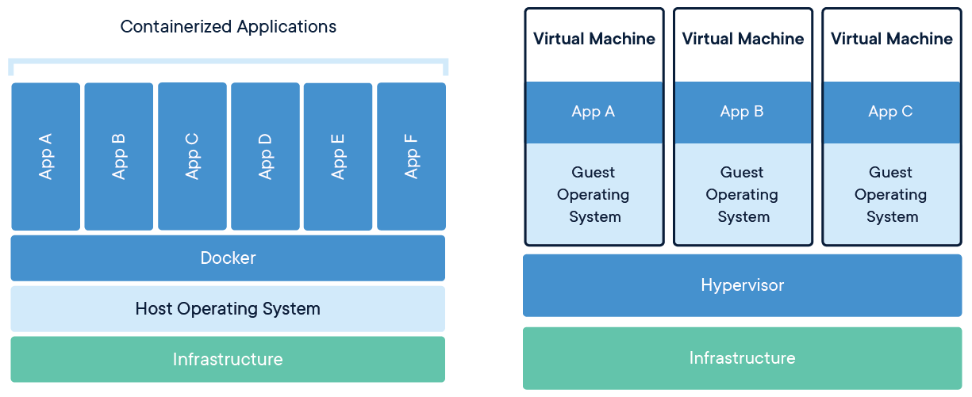

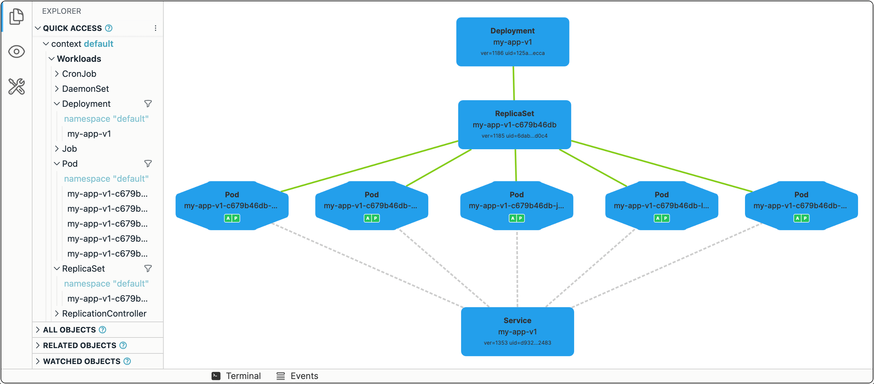
Day 27
▶ Docker for Spring Boot
- Dockerfile
- Multi-stage builds
Day 28
▶ Docker Compose
- Running all microservices locally
Day 29
▶ Kubernetes Basics
- Pods
- Services
- Scaling intuition

🏁 DAY 30 — FINAL INTEGRATION & INTERVIEW VIEW
Goal: Tie everything together
Day 30
▶ End-to-End Microservices System
- User + Product + Order + Payment
- Architecture recap
- Interview Q&A
- How this maps to System Design rounds

